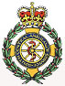

**Hayling Island Community First Responders**

Pompey FC boss Paul Cook looked in at the Hayling Community First Responders trailer during his time at the Ferry Boat Inn during a fund raising day for little Lily.

Paul is pictured here with the duty responders on the day Emma and Annie, who shortly after meeting with the man who successfully steered Pompey into League One, had to shoot off to attend the Hayling responders 290th emergency call of the year.

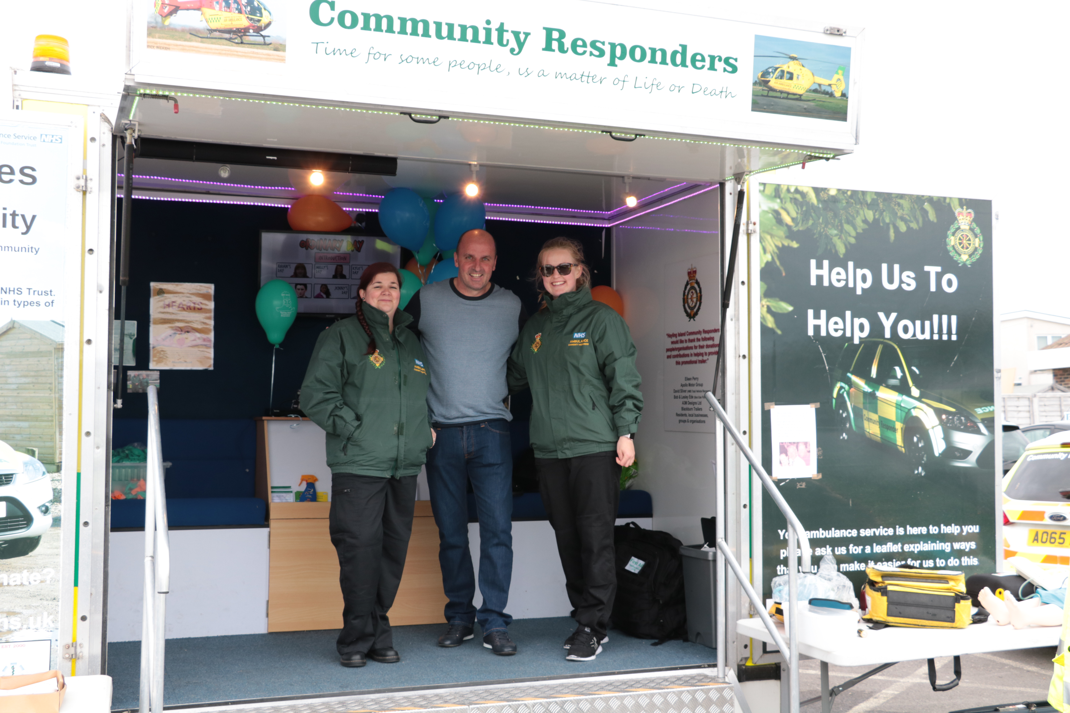

Lily’s mother Zoey suddenly passed away unexpectedly in February this year and the Ferry Boat Inn stepped in to help Lily’s dad to fund a school trip to Dubai that was the last wish that Lily’s mother made to the little girl at Christmas.

Thanks to the amazing generosity of the Ferry Boat Inn’s customers and visitors during the fund raising day the target of £1,000 was not only reached but exceeded.

Portsmouth Football club responded to the fund raising day by sending over a number of players including Enda Stevens and Gary Roberts who were key players in Pompey F.C. becoming League Two champions, together with League Two manager of the month for April, Paul Cook to help with fundraising, seen here in the main bar of the Ferry Boat Inn..

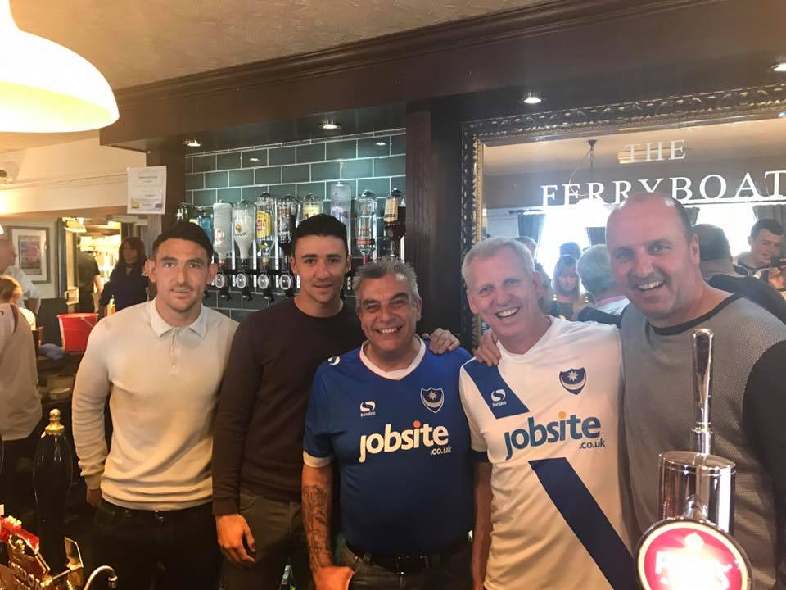

Look out for other events at the Ferry Boat Inn in the coming months including 999 Awareness day on Saturday 19th August with all your emergency services, Denmead brass band, local military units and action displays.

Photos: Sara Hill

Contact:

Co-ordinator for Hayling Community First Responders Peter Halkyayd peterveronica178@gmail.com

Sunday 7th May 2017

**Press release - immediate**