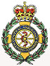

**Hayling Island Community First Responders**

On the 2nd December this year the fifth public access defibrillator [PAD] became operational outwith the West Town Inn, Station Road

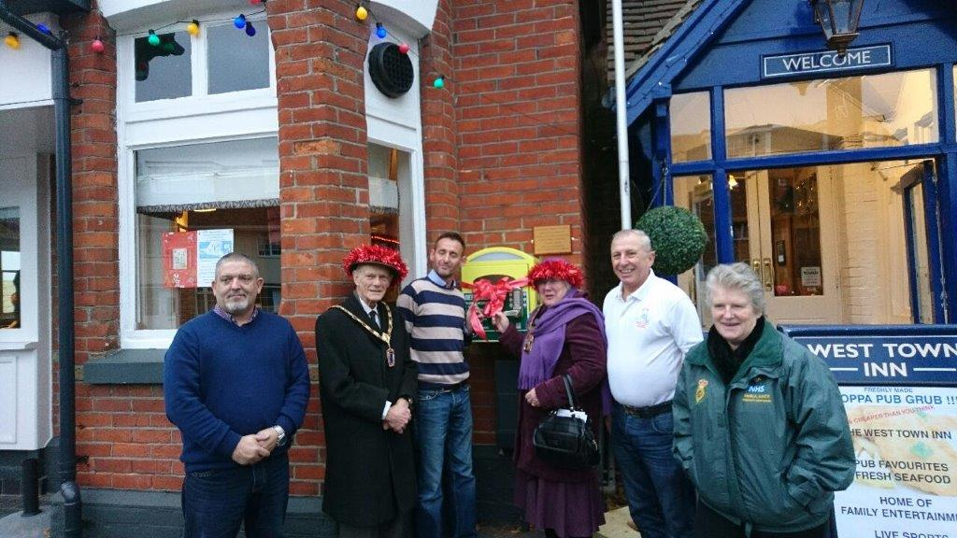

From left to right the photo shows Andy Bolt general manager of the West Town, the mayors consort Michael Ponsonby, Marcus Pingriff owner of the West Town, the mayor councillor Faith Ponsonby, Hayling community responders co-ordinator Peter Halkyard and Rosie Raines who continues to combine her day job at the Hayling surgery with that of a community responder.

The West Town Inn not only gave permission for the defibrillator to be placed in a prominate position for use by anyone of the public who need it, but will meet the annual cost of the electricity to provide light and heat to the unit.

Strengthening the community response to cardiac arrest by training and empowering more bystanders to perform CPR and by increasing the use of automated external defibrillators (AEDs) at least doubles the chances of survival and could save thousands of lives each year.

It is the donations the public kindly provide that have enabled the addition of public access defibrillators to be permanently positioned across the Island.

Over the Christmas period the West Town Inn undertook fund raising for the Hayling community responders so that more PAD’s can be provided across the Island.

By the time you read this copy of the *Hayling Islander* Marcus will have matched the 1,000 emergency calls responded to in 2016 by Hayling CFR’s with a £1 for every call, a tremendous achievement by the West Town.

With 3 tribute bands appearing at the West Town Inn over the festive period and more top rated entertainment for 2017 everyone can have both a great time and support the Island CFR’s.

Finally two new faces have recently joined the CFR team, namely Annie and Emma, with both passing their training with SCAS they are now “on the run” and have been attending calls over the Christmas & New Year period.

Over both the Christmas and New Year there were CFR’s on call as there will be over the whole of 2017. We try to cover 24hrs a day should we be needed and while we hope we did not have to call on you over the holidays, as we are one group of people you do not want knocking on your door, we do hope to see you at the many public events we will be attending with our public relations trailer throughout the year.

From all the responders we thank you all for your support over the years as without it we

could not operate and be there when you need us.

**Remember 999 for emergency calls and 111 for not so urgent medical help or advice.**

=========================================================

Contact:

Co-ordinator Peter Halkyayd peterveronica178@gmail.com

Draft Revised Thursday 8th December 2016 2030hrs

**Press release - immediate**