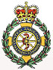

**Hayling Island Community First Responders**

**2018 finishes on a high note**

Hayling Community First Responder Co-ordinator Peter Halkyard is shown being presented with a cheque for £1,000 by Warner’s Lakeside Holiday Village General Manager Damian Skelton.

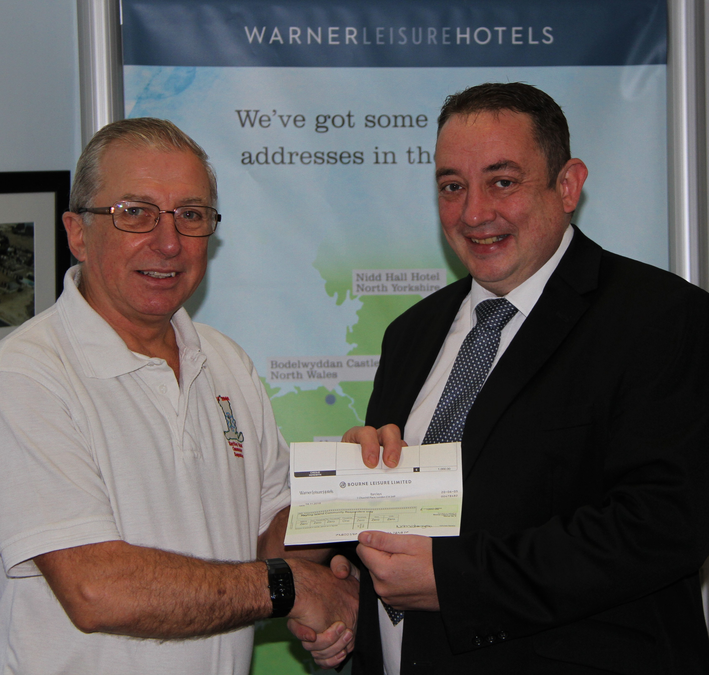

Hayling Community First Responders finished 2018 by attending a record number of emergency calls under the new ambulance categorisation system introduced in October 2017. Over 1,100 calls were responded to across all 4 categories from cardiac arrests, strokes and heart attacks to falls and welfare. With the additional calls come extra costs the CFR’s must raise money to fund, which is why the generous donation from Warner’s Lakeside is very welcome.

For example:-

£ 18                 pays for a replacement set of defibrillator pads

£156                pays for a defibrillator battery

£180                pays for the annual rental charges on a CFR emergency pager

£1000              pays for a new automated external defibrillator

£2000              pays for a new, full first responder medical kit

In attempting to provide a 24hr 7 day a week cover, the Hayling group run with 3 first responder medical kits, plus a fully equipped Ford Focus estate response car.

In addition, as readers of the Islander will know, donations and sponsorship have enabled Peter to personally install 12 public access defibrillators across Hayling and have them registered in the SCAS main control rooms.

While we hope to see as many people as possible at the varied events we attend on Hayling over the year, we also hope we do not have to come calling to see you in our role as community first responders.

A Happy New year and we extend our thanks to Warner’s Lakeside and all those individuals and businesses that have so generously supported us throughout 2018

Contact:

Coordinator Peter Halkyard peterveronica178@gmail.com

Thursday 13th December 2018

**Press release - immediate**