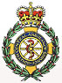

**Hayling Island Community First Responders**

A major problem for both the Islands Community First Responders and the ambulance service is rapid identification of the premises in which a medical emergency has occurred.

Now Hayling Hardware Ltd. has joined forces with the *Hayling Islander* and the Community First Responders to provide an affordable solution.

While individual house numbers and names are in many cases almost impossible to see clearly when approaching in a vehicle, particularly in poor visibility caused by weather conditions or in the hours of darkness, the large photoluminecent numbers that can be applied to the sides of the council wheelie bins are clear and easy to see.

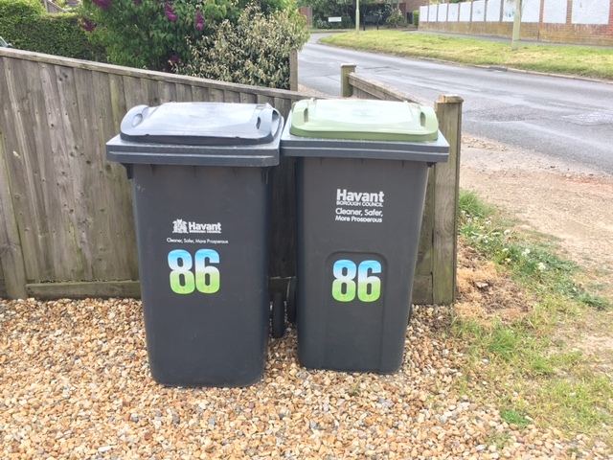

By taking in this article from the *Hayling Islander* to Hayling Hardware in Elm Grove, a massive discount of 33% will be given off the purchase of up to 6 yellow or red photoluminecent wheelie bin numbers.

Director of Hayling Hardware Ltd Rob Adams said “We are pleased to provide this special offer in support of the Island residents, being well aware from the deliveries we make around the Island how difficult it can be to easily identify individual premises”.

Time is of the essence in attending many medical emergencies from cardiac arrest to strokes and every household can help the community responders to meet the 8 minute target time for response to life threatening Red calls by clearly identifying their property.

We urge all Hayling households to take this copy of the *Islander* to Hayling Hardware and take advantage of the offer to obtain 6 photoluminecent wheelie bin numbers and help us to help you.

Contact:

Co-ordinator for Hayling Community First Responders Peter Halkyayd peterveronica178@gmail.com

Date: 8th 2017

**Press release - immediate**