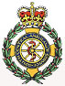

**Hayling Island Community First Responders**

**NHS England declare Major Incident**

The Christmas/New year holidays saw an extraordinary end to 2017 and beginning of 2108 for the Islands Community First Responders.

By the year end of 2017 Hayling First Responders had attended a total of 1,072 priority emergency calls and while a relatively high rate of calls over the winter months is not unexpected what happened next was.

**“NHS England have declared a demand related Major Incident due to the demand and hospital issues in the South East of Hampshire”.** Timed at 1643hrs. on Sunday 31st December 2017 this unprecedented communication via South Central Ambulance Service came as the volume of both 111 and 999 calls coming into the SCAS control room in Otterbourne, together with mass numbers of patients attending Queen Alexandra Hospital in Portsmouth combined to create a perfect storm.

This saw Haylings CFR’s responding with maximum resources and multiple personnel 24hrs a day over the holiday period. Individual incidents saw the responders waiting with patients for anything up to 2 hours where an ambulance was required, while a number of patients were assisted to stay at home after telephone discussions with senior medical staff in the SCAS control room.

This resulted in a timely response to patients that would otherwise have had a longer wait for assistance, and ensuring ambulances were kept available for any Life-Threatening emergencies.

As this is being compiled the number of calls shows no signs of letting up and already this year the Hayling CFR’s will have responded to over 100 incidents by the time you read the *Hayling Islander.*

During this busy time a new responder Amie Newman, who you will see when you visit Whistler’s Fish and Chip shop in West Town, completed her training to join the team and was immediately in the thick of the action. Amie is shown in the photo with Sharon Hammond of the New Town House Hotel handing Amie money donated by the New Town customers over the Christmas period for the use of Hayling community first responders.

We would like to thank Sharon, her customers and all those who donate to the Islands responders, with 100% of every donation going directly to fund equipment, vehicle costs and replacement kit.

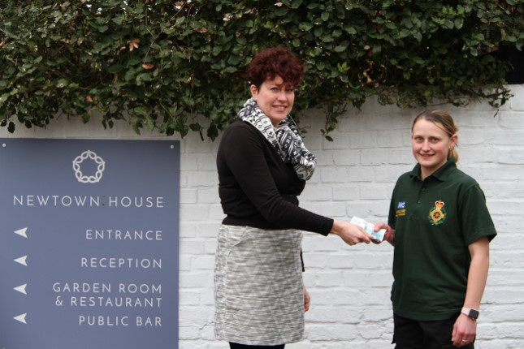

In addition to answering emergency calls on Hayling, a number of the Islands responders carried out duties as ambulance crew with private ambulance services providing medical support at large events over Christmas and New year. This again reducing the pressure on front line emergency ambulance services.

Be assured the Island first responders will continue to be available throughout 2018 and we would like to say a massive thank you to all those organisations and individuals for the generous donations that kept the group running throughout 2017 and into 2018.

Contact:

Co-ordinator for Hayling Community First Responders Peter Halkyard peterveronica178@gmail.com

Date: 12th January 2018

**Press release - immediate**